

Wireframe design

Credit Card Default Prediction



Homepage

Homepage consist of different sections with buttons and descriptions. Here is the basic wireframe of the homepage.

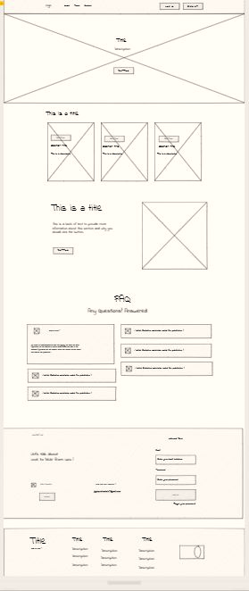

The **Crossed Section**s in above sample can be used for images as background to give user a good experience.

Artifacts Page

In this page the files artifacts files and folders are shown.

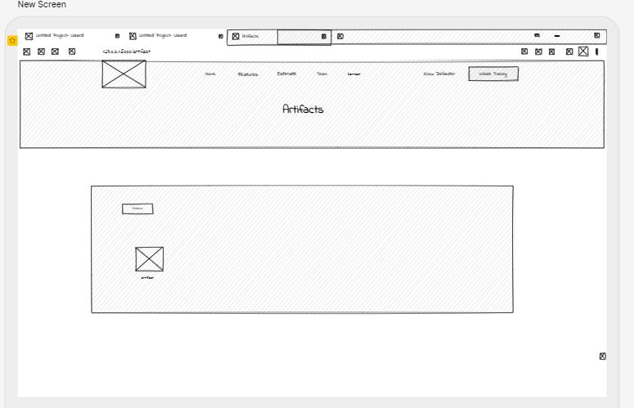

Models Page

In this page all the created models are saved in a file with creation time.

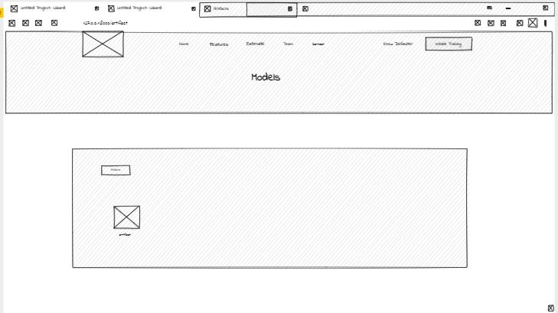

Log Page

All the log files are shown in this page with time tag.

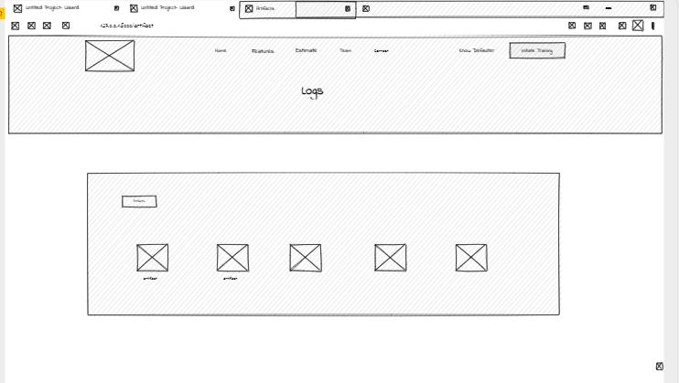

History Page

All the training history with experiment id, time, accuracy score is shown here.

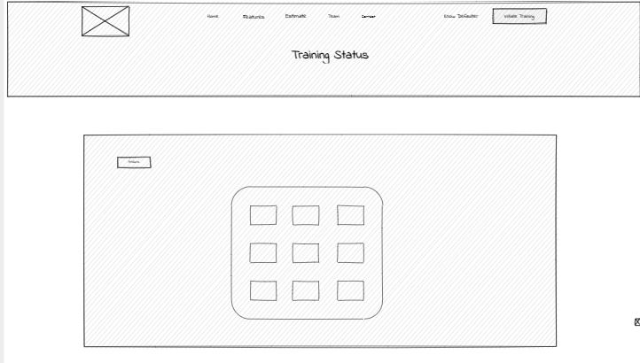

Predict Page

Prediction on the basis of given entries can be done on this page.

